PROJECT DOCUMENTATION
STREAMLINING IT PROCUREMENT:
AUTOMATING STANDARD LAPTOP ORDERS WITH FLOW DESIGNER

Name:1.Sithi Rihana S M (Team Lead)
2. Jainambu Mufliha A S (Member)
3. Katheeja Najmiya M M (Member)
4. Aysha Naleefa (Member)
Date: 26/09/26

Project Name:
Streamlining IT Procurement: Automating Standard Laptop Orders with Flow Designer

TABLE OF CONTENTS
S. No. | CONTENT
1 | INTRODUCTION
1.1 | Project Overview
1.2 | Purpose
2 | IDEATION PHASE
2.1 | Problem Statement
2.2 | Empathy Map Canvas
2.3 | Brainstorming
3 | REQUIREMENT ANALYSIS
3.1 | Customer Journey Map
3.2 | Solution Requirement
3.3 | Data Flow Diagram
3.4 | Technology Stack
4 | PROJECT DESIGN
4.1 | Problem Solution Fit
4.2 | Proposed Solution
4.3 | Solution Architecture
5 | PROJECT PLANNING & SCHEDULING
5.1 | Project Planning
6 | FUNCTIONAL AND PERFORMANCE TESTING
6.1 | Performance Testing
7 | RESULTS
7.1 | Output Screenshots
8 | ADVANTAGES & DISADVANTAGES
9 | CONCLUSION
10 | FUTURE SCOPE
11 | APPENDIX

1. INTRODUCTION

1.1 Project Overview
IT procurement is an important process in an organization because employees require suitable IT equipment to perform their daily work. One of the common requirements is providing standard laptops to employees. The procurement process generally involves request submission, approval, task assignment, procurement processing, and final fulfilment.
When these activities are handled manually, the process can become time-consuming. Employees may have to wait for approvals, contact different teams for updates, and repeatedly follow up on their requests. IT and procurement teams may also have to perform repetitive activities such as creating tasks, assigning tasks, updating statuses, and communicating with employees.
To overcome these challenges, this project proposes an automated standard laptop procurement workflow using the ServiceNow platform and Flow Designer.
The project titled “Streamlining IT Procurement: Automating Standard Laptop Orders with Flow Designer” focuses on automating the workflow for a standard laptop request.
The employee submits a laptop request through ServiceNow. Once the request is submitted, Flow Designer automatically controls the required workflow. The process includes approval, task creation, task assignment, procurement processing, status updates, notifications, and request completion.
The automation reduces unnecessary manual intervention and provides a structured method for processing laptop requests. It also improves request visibility and helps the responsible teams manage procurement activities efficiently.

Main Workflow
Employee → Laptop Request → Flow Designer → Approval → IT/Procurement Task → Task Assignment → Laptop Fulfilment → Status Update → Completion
The project demonstrates the practical use of ServiceNow Flow Designer for automating an IT procurement process.

1.2 Purpose
The main purpose of this project is to automate the standard laptop procurement process using ServiceNow Flow Designer.
The system is designed to reduce manual processing and provide a structured workflow from the initial request to final completion.
The major purposes of the project are:

1. To simplify the standard laptop request process.

2. To automate the approval workflow.

3. To automatically create required procurement or IT tasks.

4. To assign tasks to the appropriate team or user.

5. To reduce repetitive manual activities.

6. To provide better visibility of request status.

7. To improve communication through notifications.

8. To maintain request information in a centralized ServiceNow environment.

9. To provide a consistent and organized procurement workflow.
---

2. IDEATION PHASE

2.1 Problem Statement
In an organization, employees may require laptops for their work. The process of obtaining a laptop can involve several stages, including submitting a request, obtaining approval, assigning the request to the responsible team, processing the order, and completing the request.
When these activities are performed manually, several problems can occur. Request processing may take more time, approvals may be delayed, and tasks may need to be manually created and assigned. Employees may also have limited visibility of the progress of their requests.
IT and procurement teams may need to repeatedly perform similar activities for every laptop request. Manual communication can also result in delays and information gaps.
Therefore, there is a need for an automated system that can manage the standard laptop procurement process in a structured and consistent manner.
The proposed project uses ServiceNow Flow Designer to automate the workflow.
The proposed process is:
Employee Request → Approval → Automated Task Creation → Task Assignment → Procurement Processing → Status Update → Completion

2.2 Empathy Map Canvas

User Persona
Primary User: Employee requesting a standard laptop
The employee needs a standard laptop for work and expects the procurement process to be simple, fast, transparent, and easy to track.

Think and Feel
• “I need a laptop for my work.”
• “I want the request process to be simple.”
• “I do not want unnecessary delays.”
• “I want to know the current status of my request.”
• “I should not have to repeatedly contact the IT team.”

See
The employee may see different stages such as request submission, approval, processing, and fulfilment.

Hear
The employee may receive information from the manager, IT team, procurement team, or system notifications regarding the request.

Say and Do
The employee submits the request, provides the required information, waits for approval, checks the status, and receives the laptop after the request is processed.

Pain Points
• Manual request processing
• Approval delays
• Repeated follow-up
• Limited status visibility
• Manual task assignment
• Communication gaps
• Repetitive activities

Needs and Gains
• Faster processing
• Automated workflow execution
• Status visibility
• Reduced manual effort
• Better communication

Key Insight
Employees need a simple, transparent, and automated laptop procurement process that reduces unnecessary waiting and follow-up.

2.3 Brainstorming
Brainstorming was performed to identify possible solutions for improving the standard laptop procurement process.
Several ideas were considered:

1. Online laptop request submission

2. Automated approval workflow

3. Flow Designer automation

4. Automatic task creation

5. Automatic task assignment

6. Automated status updates

7. Notification system

8. Centralized request tracking

9. Request history maintenance

10. Automated request completion
The selected idea was to automate standard laptop orders using ServiceNow Flow Designer.
The selected solution provides a structured workflow connecting request submission, approval, task creation, assignment, processing, status updates, and completion.
---

3. REQUIREMENT ANALYSIS

3.1 Customer Journey Map
The Customer Journey Map describes the different stages experienced by an employee while requesting a standard laptop.

1. Identifying the Need
The employee identifies the need for a standard laptop to perform work-related activities.

2. Submitting the Request
The employee submits the laptop request through ServiceNow and provides the required information.

3. Request Review and Approval
The submitted request is processed through the defined approval workflow. The required approver reviews the request.

4. Procurement Processing
After approval, the automated workflow creates the required IT or procurement task. The responsible team processes the laptop order.

5. Laptop Fulfilment
The laptop procurement process is completed and the laptop is prepared for the employee.

6. Request Completion
The request status is updated after the procurement process is completed. The employee receives the required status update.
Customer Pain Points
• Manual processing
• Approval delays
• Repeated follow-up
• Limited visibility
• Manual task assignment
• Communication gaps
Opportunities for Improvement
• Automated request processing
• Automated approval
• Automatic task creation
• Automatic task assignment
• Status tracking
• Notifications

3.2 Solution Requirement

Functional Requirements
The system should:

1. Allow employees to submit a standard laptop request.

2. Capture required employee and laptop request information.

3. Create a request record in ServiceNow.

4. Trigger the Flow Designer workflow.

5. Process the required approval.

6. Automatically create procurement or IT tasks.

7. Assign tasks to the responsible team or user.

8. Update the request status.

9. Generate required notifications.

10. Maintain request information for tracking.

Non-Functional Requirements
Usability: The request process should be simple and easy to understand.
Reliability: The workflow should execute consistently.
Security: Access to requests and related information should be controlled using appropriate permissions.
Efficiency: Automation should reduce unnecessary manual processing.
Maintainability: The workflow should be easy to modify when requirements change.

User Requirements
• Employee
• Approver
• IT/Procurement Team
• System Administrator

System Requirements
• ServiceNow instance
• Service Catalog
• Flow Designer
• Request and task records
• Approval configuration
• Notification configuration
• Appropriate roles and permissions
• Computer or laptop
• Internet connection
• Web browser

3.3 Data Flow Diagram
The Data Flow Diagram represents how information moves through the automated standard laptop procurement system.

Main Entities
• Employee
• ServiceNow
• Flow Designer
• Approver
• IT/Procurement Team

Main Data Flow
Employee → Laptop Request → ServiceNow → Flow Designer → Approval → IT/Procurement Task → Status Update → Employee

Level 0 DFD
Employee → Standard Laptop Procurement System → IT/Procurement Team

Level 1 DFD

1. Submit Laptop Request

2. Store Request Information

3. Trigger Flow Designer

4. Process Approval

5. Create Procurement Task

6. Assign Task

7. Process Laptop Order

8. Update Request Status

9. Notify Employee

10. Complete Request

Data Stored
• Employee details
• Laptop request details
• Approval information
• Task information
• Request status
• Processing details

3.4 Technology Stack

ServiceNow
ServiceNow is the primary platform used for implementing the project. It provides the environment required to create and manage the laptop procurement workflow.

Service Catalog
Service Catalog provides the interface through which employees can submit the standard laptop request.

Flow Designer
Flow Designer is the main automation component of the project. It controls the workflow after the laptop request is submitted.
It supports automated processes involving triggers, actions, conditions, approvals, tasks, notifications, and record operations.

ServiceNow Tables
ServiceNow tables store and manage request, task, user, approval, and status-related information.

Notifications
Notifications are used to communicate important events such as request submission, approval, processing, and completion.

Roles and Permissions
Roles and permissions help control access to the required records and functions.

Overall Technology Flow
ServiceNow Service Catalog → Laptop Request → Flow Designer → Approval → IT/Procurement Task → Status Update → Notification
---

4. PROJECT DESIGN

4.1 Problem Solution Fit
The project was designed to address the major problems identified in the manual laptop procurement process.
The existing process may involve manual request handling, approval delays, repetitive task assignment, communication gaps, and difficulty tracking request progress.
The proposed ServiceNow solution addresses these problems through workflow automation.
Flow Designer automatically controls the required activities after a request is submitted. Approval can be processed through the workflow, and required tasks can be created and assigned automatically.
The solution also provides better tracking because request and task information are maintained within ServiceNow.

Expected Benefits
• Reduced manual processing
• Better request tracking
• Improved task management
• Reduced repetitive work
• Better communication
• Consistent workflow
• Improved process efficiency

4.2 Proposed Solution
The proposed solution uses ServiceNow and Flow Designer to automate the standard laptop procurement process.

Working of the Proposed Solution

1. Request Submission
The employee submits a standard laptop request through ServiceNow.

2. Request Creation
ServiceNow creates and stores the request information.

3. Flow Trigger
Flow Designer is triggered when the required condition is satisfied.

4. Approval
The request is sent to the appropriate approver.

5. Task Creation
After the required approval, the system automatically creates the required IT or procurement task.

6. Task Assignment
The task is assigned to the appropriate responsible team or user.

7. Procurement Processing
The IT or procurement team processes the laptop order.

8. Status Update
The request status is updated according to the progress of the process.

9. Notification
The employee receives relevant notifications regarding the request.

10. Completion
After the procurement process is completed, the request is marked as completed.

4.3 Solution Architecture

Employee Layer
The employee initiates the process by submitting a standard laptop request.

ServiceNow Request Layer
ServiceNow receives the request and stores the required information.

Flow Designer Layer
Flow Designer controls the automated workflow and executes the required actions.

Approval Layer
The approval stage ensures that the request is reviewed before further processing.

IT/Procurement Layer
The responsible team receives the automatically generated task and processes the laptop order.

Data Layer
ServiceNow records store request, task, approval, user, and status information.

Notification Layer
Notifications communicate important workflow updates to the employee.

Overall Architecture
Employee → ServiceNow Service Catalog → Laptop Request → Flow Designer → Approval → IT/Procurement Task → Laptop Fulfilment → Status Update → Notification → Completion
---

5. PROJECT PLANNING & SCHEDULING

5.1 Project Planning
Project planning defines the activities required to successfully develop and complete the automated standard laptop procurement project.

Project Objective
The main objective is to design and implement an automated standard laptop procurement workflow using ServiceNow Flow Designer.

Project Planning Activities

Requirement Analysis
The requirements of the project are identified and analyzed.

Problem Identification
The problems associated with manual laptop procurement are studied.

Solution Design
The proposed automated workflow and architecture are designed.

ServiceNow Configuration
The required ServiceNow components are configured.

Flow Designer Development
The automation flow is created and configured.

Testing
The request submission, approval, task creation, task assignment, status updates, and notifications are tested.

Error Correction
Errors identified during testing are analyzed and corrected.

Final Demonstration
The complete automated laptop procurement workflow is demonstrated.

Documentation
The final project documentation is prepared with diagrams, testing details, results, advantages, disadvantages, conclusion, and future scope.

Project Workflow
Requirement Analysis → Problem Identification → Solution Design → ServiceNow Configuration → Flow Development → Testing → Error Correction → Demonstration → Documentation

Resources Required
• ServiceNow instance
• Service Catalog
• Flow Designer
• Computer or laptop
• Internet connection
• Web browser
• Documentation tools

Risk Planning
Possible risks include:
• Incorrect workflow configuration
• Approval failures
• Task assignment problems
• Notification failures
• Testing errors
These risks can be reduced through proper configuration, repeated testing, validation, and correction of identified issues.

Expected Project Outcome
The expected outcome is a working ServiceNow workflow that automates standard laptop procurement and reduces unnecessary manual processing.
---

6. FUNCTIONAL AND PERFORMANCE TESTING

6.1 Performance Testing
Performance Testing is performed to verify whether the automated laptop procurement workflow operates efficiently and reliably.
The testing focuses on the ServiceNow request process and Flow Designer workflow.

Testing Objectives

1. To verify system response during request submission.

2. To verify Flow Designer execution.

3. To check approval processing.

4. To verify automatic task creation.

5. To verify task assignment.

6. To check status updates.

7. To verify notifications.

8. To identify workflow delays or errors.

9. To verify consistent system performance.

Testing Process
The testing begins by submitting a standard laptop request through ServiceNow.
The request creation and system response are observed. After submission, the Flow Designer workflow is monitored to ensure that it starts correctly.
The approval stage is tested, followed by task creation and assignment. The request status is checked during each stage.
Notifications are also verified to ensure that important updates are communicated correctly.
The complete workflow is then tested from request submission to completion.

Functional Verification
The following functions are verified:
• Laptop request submission
• Request record creation
• Flow Designer trigger
• Approval
• Task creation
• Task assignment
• Status update
• Notification
• Request completion

Performance Factors
The main factors considered are:
• System response time
• Flow execution
• Approval processing
• Task creation
• Task assignment
• Status update
• Notification delivery
• Workflow reliability

Expected Outcome
The system should process laptop requests smoothly and execute the required automated workflow without unnecessary delays or failures.
---

7. RESULTS

7.1 Output Screenshots
The following section contains screenshots of the implemented project in the ServiceNow environment. The screenshots demonstrate the standard laptop request process, Flow Designer automation, approval, task processing, status updates, and completion of the request.
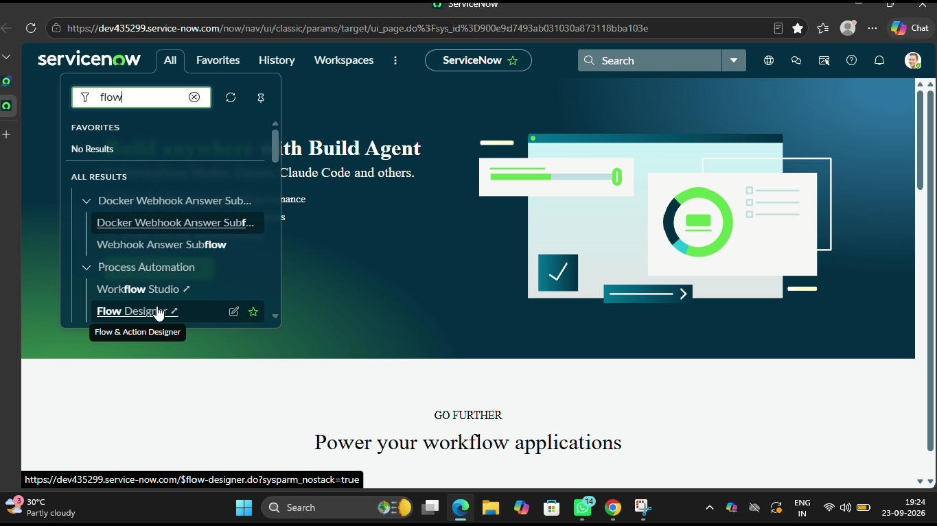
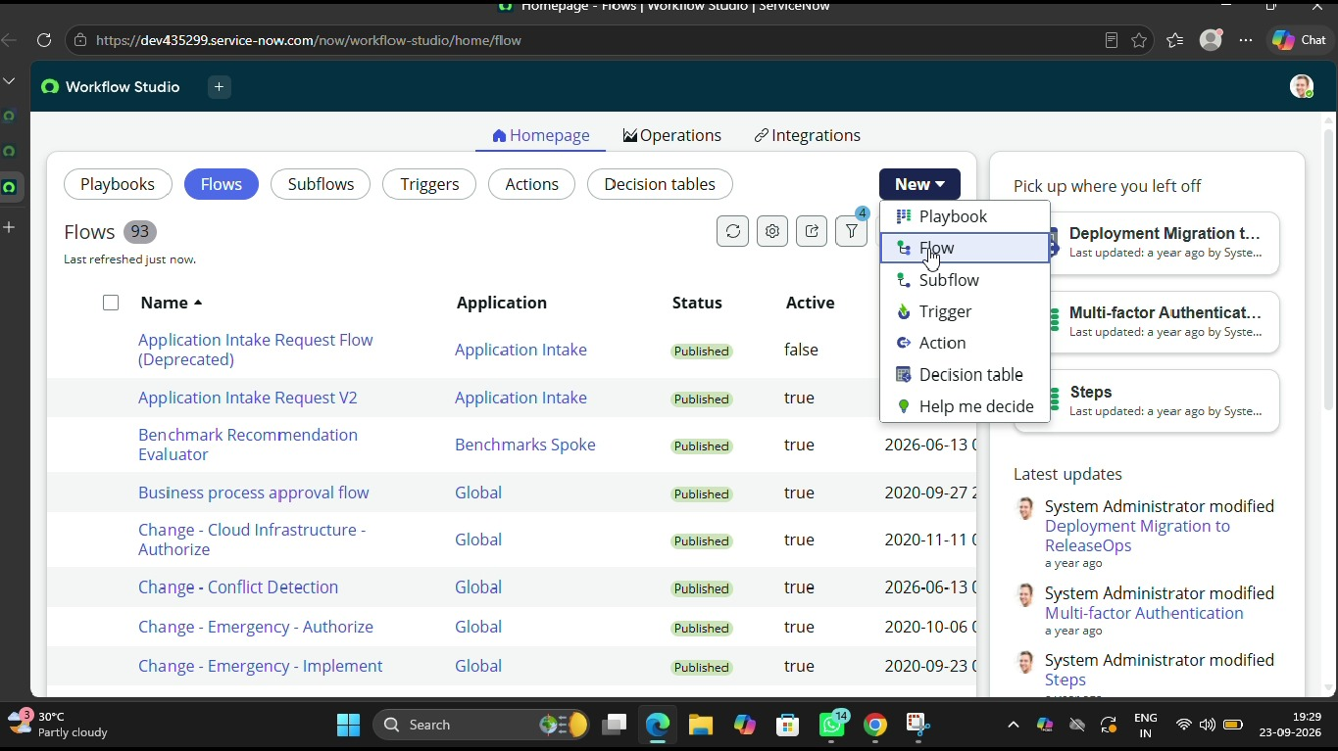
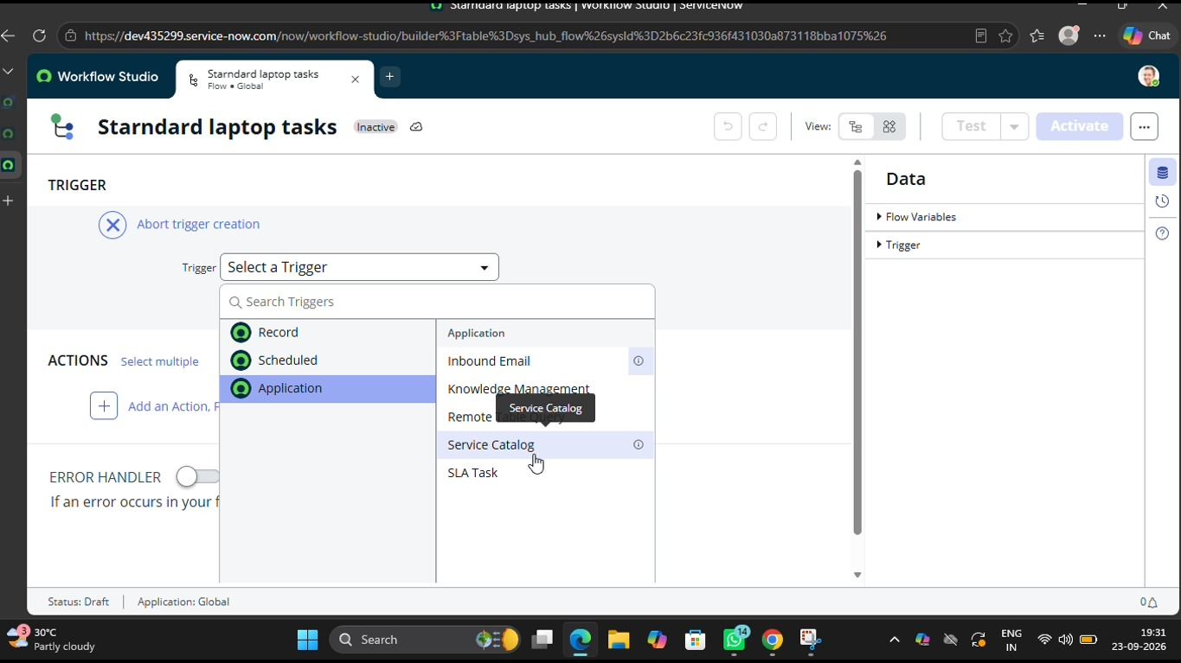
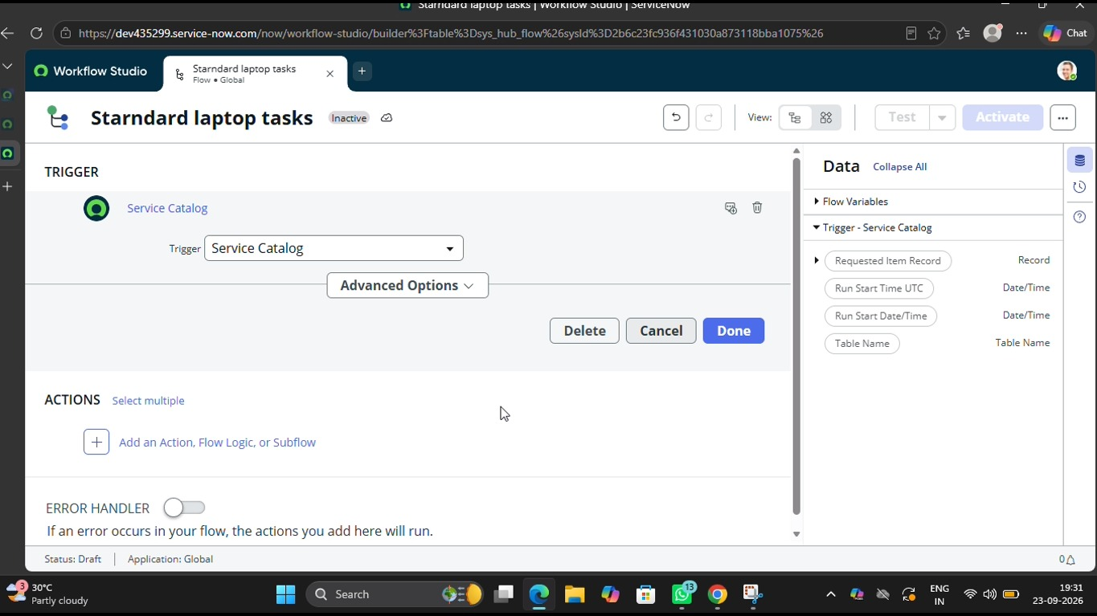
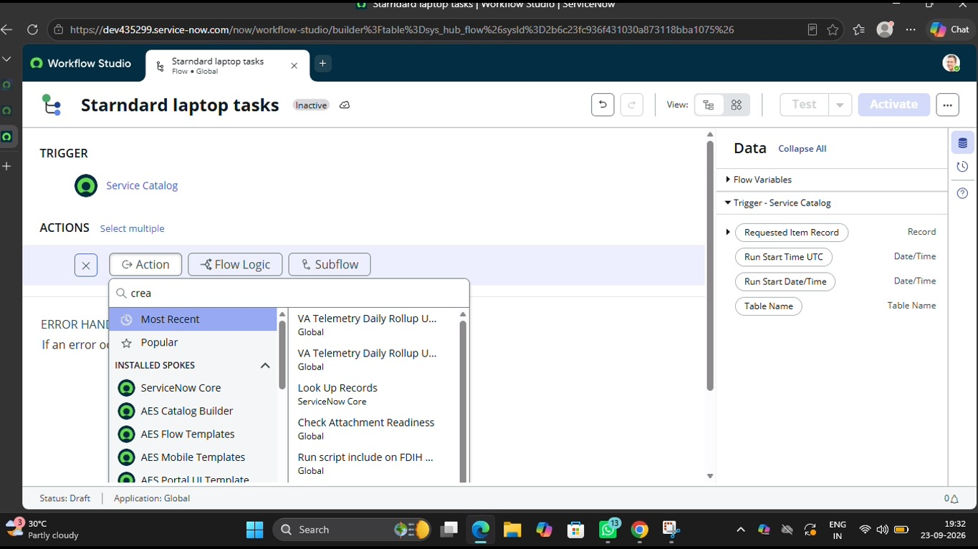
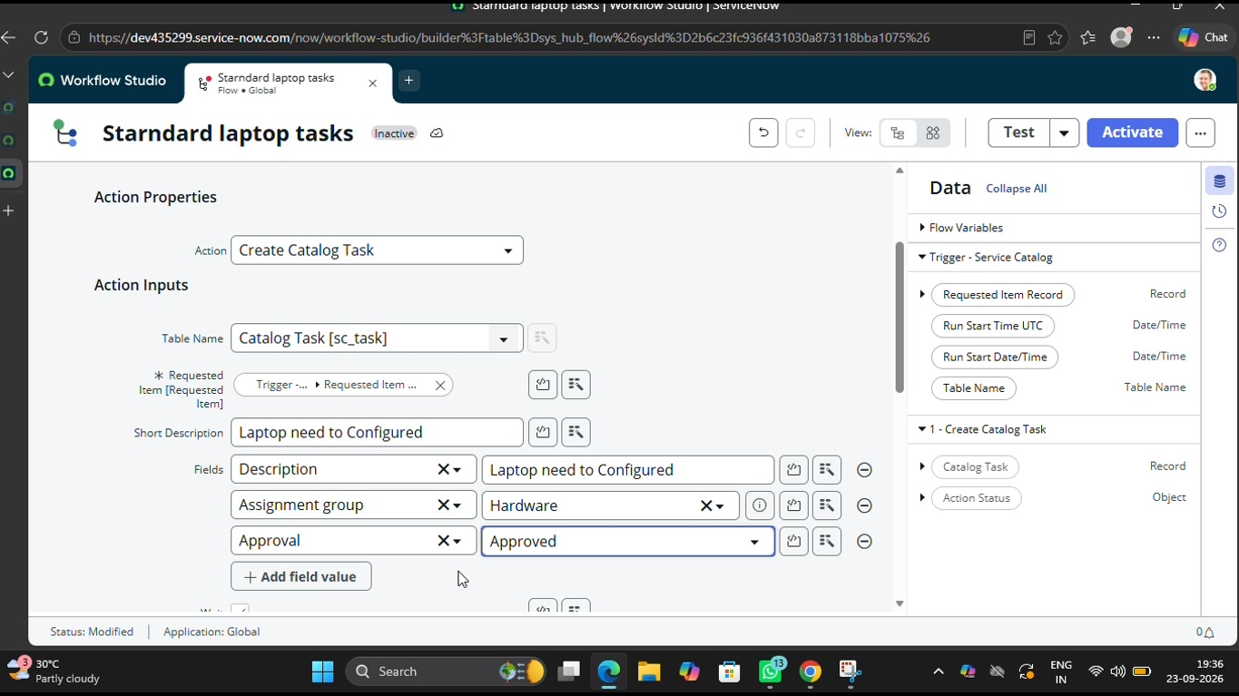
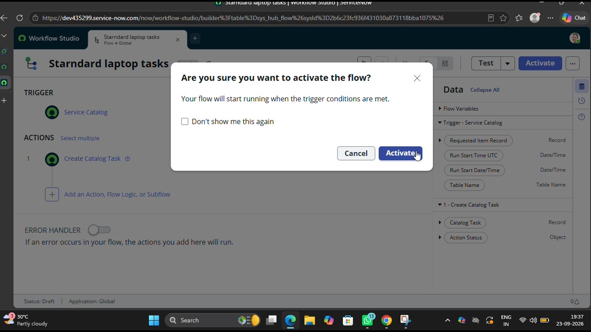
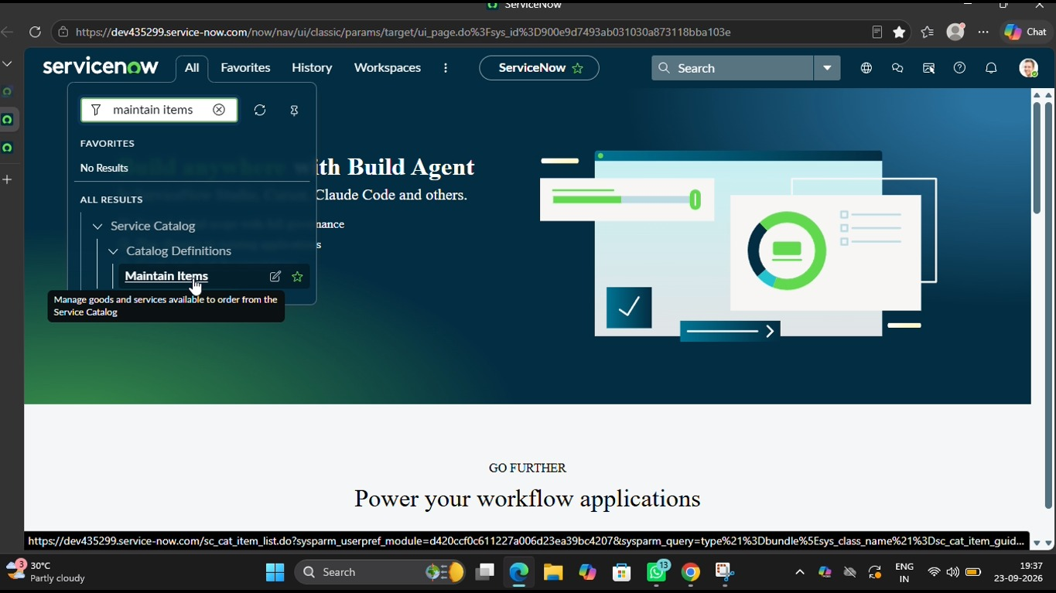
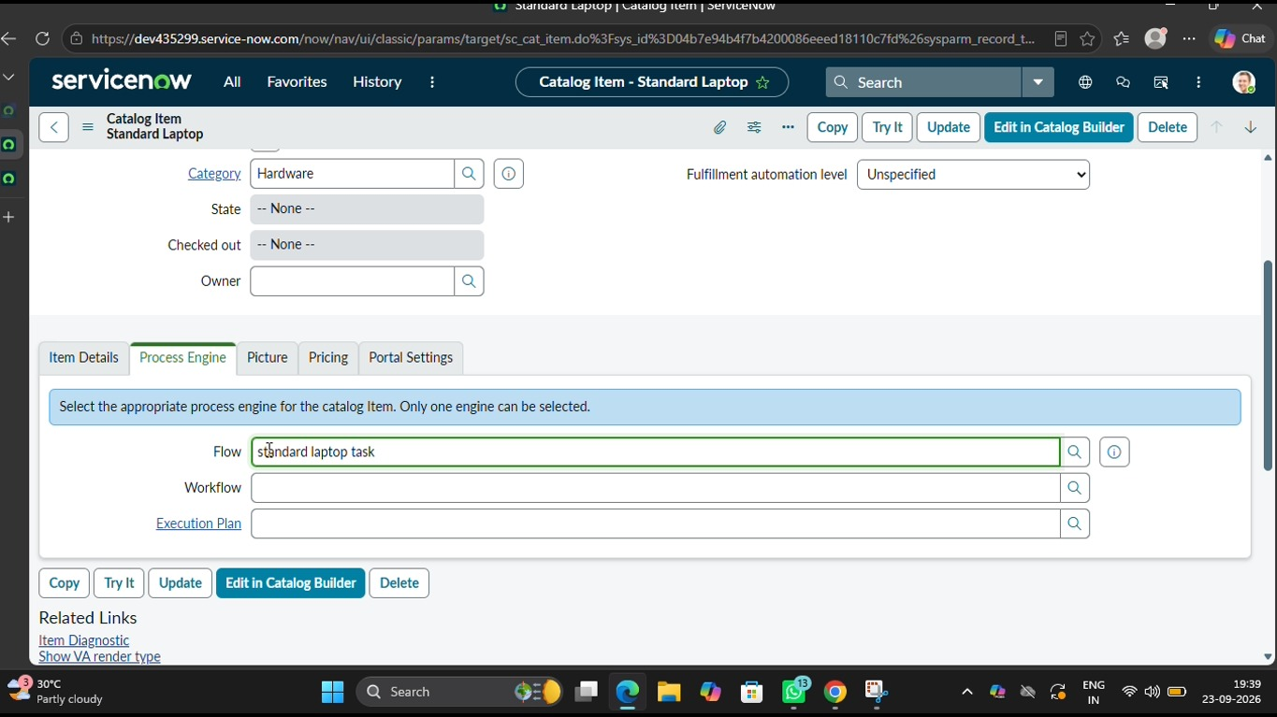
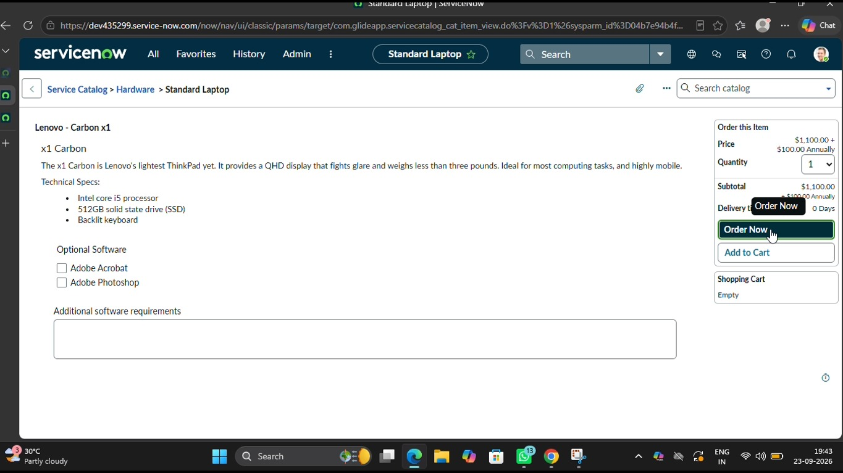
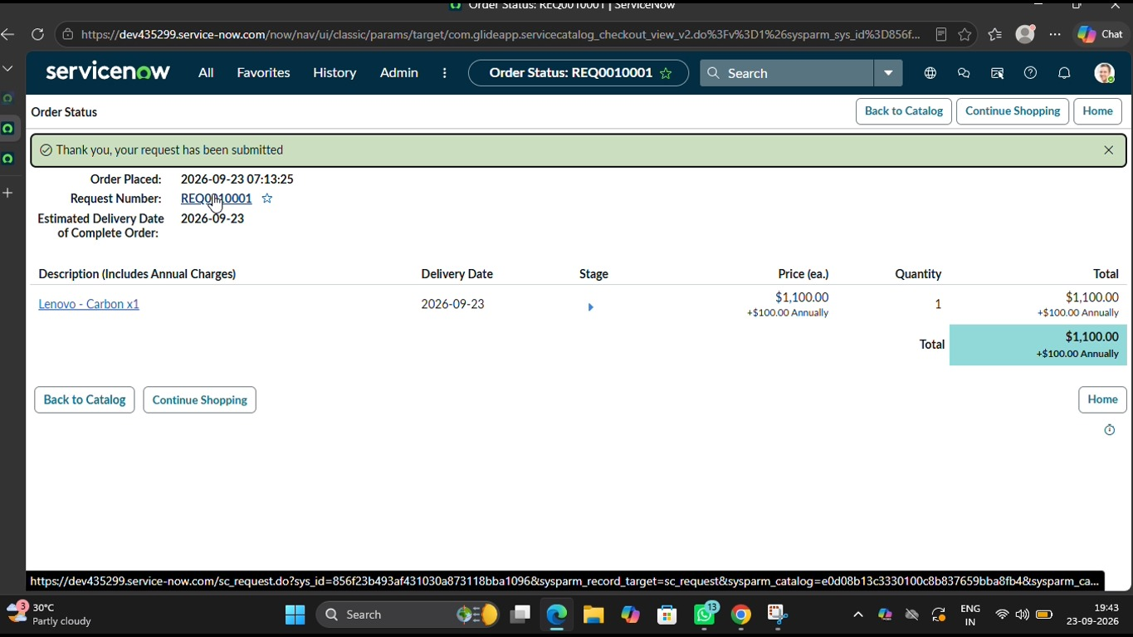
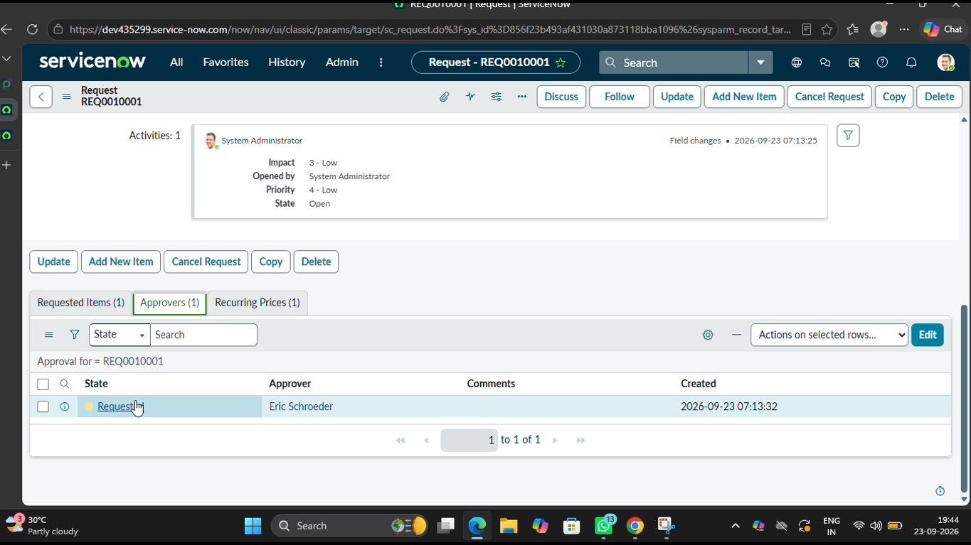
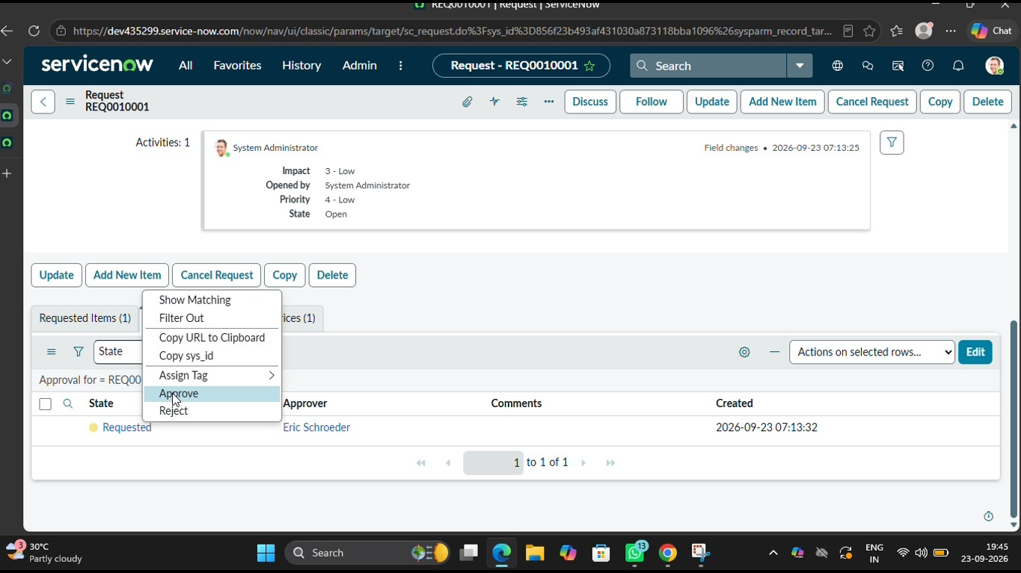
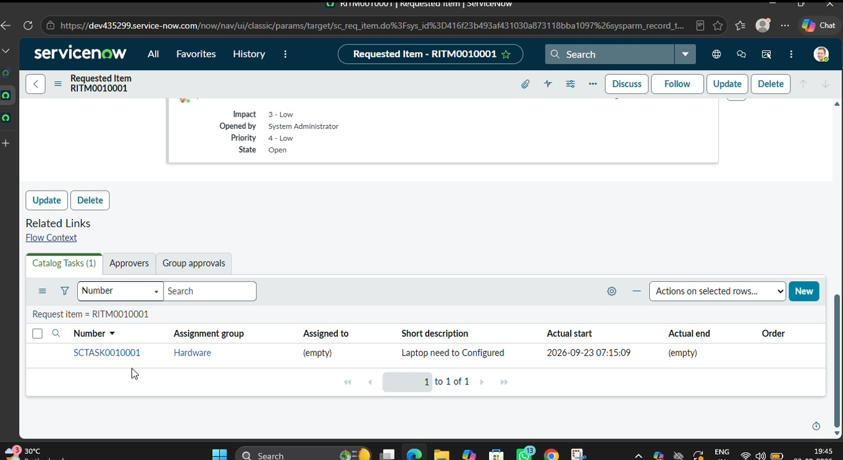
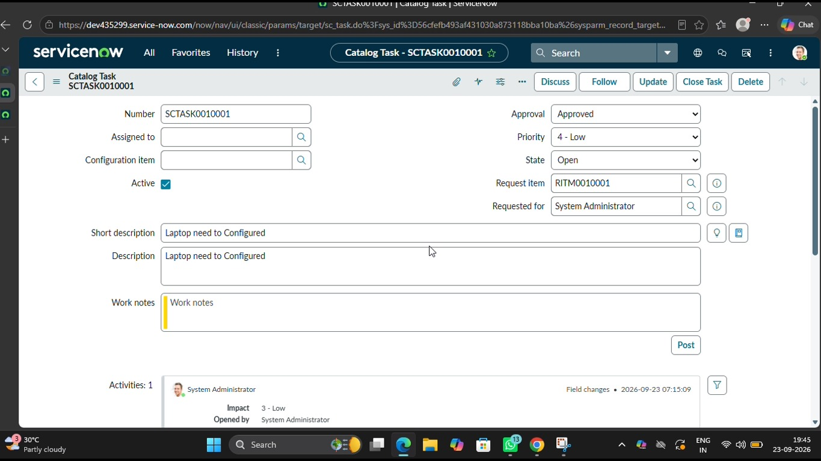

8. ADVANTAGES & DISADVANTAGES

Advantages

Reduced Manual Work
The automation reduces repetitive manual activities for IT and procurement teams.

Faster Processing
Automated workflow activities reduce unnecessary delays between different stages of the procurement process.

Automatic Task Creation
Required tasks can be created automatically after the defined conditions are satisfied.

Better Task Management
Tasks can be assigned to the appropriate team or user, making responsibilities clearer.

Improved Tracking
The request status can be monitored within ServiceNow.

Better Communication
Automated notifications help communicate important updates to employees and responsible teams.

Centralized Information
Request, approval, task, and status information can be maintained within the ServiceNow environment.

Consistent Workflow
A predefined workflow can be followed for standard laptop requests, providing a consistent procurement process.

Disadvantages

Platform Dependency
The solution depends on the availability and configuration of the ServiceNow platform.

Initial Configuration Effort
Creating and configuring the workflow requires initial development and testing effort.

Limited to Standard Requests
The project is mainly designed for standard laptop procurement and may require additional configuration for non-standard equipment.

Configuration Errors
Incorrect Flow Designer conditions or actions can affect workflow execution.

Maintenance Requirement
The workflow may require updates when organizational procurement policies or requirements change.
---

9. CONCLUSION
The project “Streamlining IT Procurement: Automating Standard Laptop Orders with Flow Designer” demonstrates how workflow automation can be used to improve the standard laptop procurement process.
The project addresses common challenges associated with manual procurement, including repetitive work, approval delays, manual task assignment, communication gaps, and limited request visibility.
By using ServiceNow and Flow Designer, the project provides a structured workflow for handling standard laptop requests. The employee can submit a request, after which the system can manage approval, task creation, task assignment, status updates, notifications, and completion.
The project also demonstrates the importance of requirement analysis, solution design, planning, testing, and documentation when developing an automated business process.
The implemented solution provides a systematic approach to standard laptop procurement and demonstrates the practical use of ServiceNow Flow Designer for IT process automation.
---

10. FUTURE SCOPE
The project can be further enhanced with additional automation and integration features.

Automated Inventory Checking
The system can be enhanced to check laptop inventory automatically before processing a request.

Vendor Integration
The system can be integrated with external vendors or procurement systems to automate purchase-related activities.

Advanced Approval Rules
Different approval workflows can be introduced based on employee department, designation, laptop type, cost, or business requirements.

Multiple Device Categories
The system can be expanded to support other IT equipment such as monitors, keyboards, docking stations, tablets, and other standard devices.

Automated Notifications
More detailed notifications can be added for different stages such as approval, procurement, shipping, delivery, and completion.

Dashboard and Reporting
A dashboard can be introduced to display the number of requests, pending approvals, completed orders, processing time, and other procurement information.

AI-Based Automation
Future versions can use AI-based features to classify requests and assist with procurement-related activities.

Integration with Asset Management
The procurement workflow can be integrated with asset management so that the issued laptop can automatically be recorded as an organizational asset.
These enhancements can make the system more comprehensive and suitable for larger organizational IT procurement processes.
---

11. APPENDIX
The appendix provides additional supporting information and project resources.

Appendix A – ServiceNow Configuration
This section contains the configuration details used for implementing the automated standard laptop procurement process in ServiceNow.

Appendix B – Flow Designer Workflow
This section provides information about the Flow Designer workflow used to automate the standard laptop procurement process.
The workflow includes request triggering, approval, task creation, task assignment, status updates, notifications, and request completion.

Appendix C – Project Demonstration Video
The project demonstration video shows the working of the automated standard laptop procurement workflow, including request submission, approval, Flow Designer execution, task processing, status updates, and completion.
Video Link:
https://drive.google.com/file/d/1Mpgs5oGhULAgoVxDhS7cDKq-gQeAwOub/view?usp=sharing

Appendix D – GitHub Repository
The GitHub repository contains the project-related files and supporting resources, if applicable.
GitHub Link:
https://github.com/razhiyaraihana61-gif/Streamlining-IT-procurement_NM-Project.git

Appendix E – Additional Project Details
This section contains additional project-related information, requirements, implementation details, and supporting material used during the development of the project.
---

